**CHAPTER 1**

**INTRODUCTION**

**1.1 OVERVIEW**

Transportation has been an important aspect of human life from the old ages.The modes of transport have been evolving and upgrading from horses and carts to hyperloops. Only after the invention of engines, the transportation became easier. The 2 and 4 stroke engines have made our trips effort less. Two wheelers and four wheelers have become more popular and user friendly among us. The usage of the vehicles is increasing day by day. Now, the fuels used for powering these engines must be taken in account. There are numerous fuels used for this purpose, which mostly fall under two categories, renewable and non-renewable resources. Both has its own advantages and disadvantages.

**1.2 RELATED STUDY**

**1.2.1 FUELS**

The evolution of fuels used in today’s automotive industry is very well known to everyone. In the pre-automotive ages, people used firewood as fuel. No automotive was invented till then of course. With this, they started using the coal present on the ground and when they used up all of it, miners started digging the ground for more coal. This was the revolutionary point where Thomas New common invented a coal-burning steam engine to pump out water and allow miners to dig deeper. Further, James Watt made some improvements in the engine and made it fit for other uses as well. Most of us know that trains used to run on steam-powered engines and therefore, this is one of the largest used automotive power sources from the past. The next important fuel is the petrol or gasoline. It became a commonly used automotive fuel. In 1876, Nicolaus Otto invented the petrol engine and its working cycle is named after him only. Another commonly used petroleum product as an automotive fuel is diesel..

**1.2.2 CONVENTIONAL FUELS**

When a source of Energy cannot be reused after using it once, we call them a conventional Source of Energy. The conventional Sources of Energy are fixed and harmful to the environment. It can be further categorized into two divisions, such as

1. Commercial sources of Energy (such as coal, petroleum, nuclear energy,

natural gas, etc.)

2. Non-commercial sources of Energy (such as firewood, straw, dried dung,

etc.)

**1.2.3 ADVANTAGES**

1. The efficiency of the energy sources is high.

2. The production expenses are low.

3. The raw materials of conventional Sources of Energy are easy to transport. Raw materials such as coal, petroleum, natural gas can be transported easily through trains or ships from one place to another.

4. Generally, it doesn’t need any specific place for installation. The government can easily set up a conventional plant according to their requirements. Such as if the government wants to install a thermal plant in Uttarkhand or in Jammu, they can easily install it.

5. Though it can generate energy instance, so there is no need to wait and it produces much energy as the requirements.

**1.2.4 DISADVANTAGES**

1. They are the main reason for the pollution. Because it is released carbon monoxide from polluters into the atmosphere. According to The International Energy Agency, only in 2018, India emitted 2,299 million tonnes of carbon monoxide. This report also said that India’s per capita emissions were about 40% of the global average and contributed 7% to the global carbon dioxide burden.

2. Generating radioactive waste. We all know about the Fukushima Daiichi nuclear disaster which happened in 2011. Recently Japanese government has decided to release radioactively contaminated water into the ocean.But the environmentalists warn that it should be harmful to ocean life.

3. High start-up cost. According to the government estimate, the cost may be about 50 to 70 crores INR for setting up a 10 MW thermal power unit.Whereas to set up a nuclear power plant, it is required ₹60,000 crores.

**1.2.5 NON CONVENTIONAL FUELS:**

These types of resources get renewed or replenished fast for that reason, it is also known as renewable energy or clean energy.

Example: solar energy, wind energy, hydro energy, tidal energy, etc.

**1.2.6 ADVANTAGES:**

1. Non-conventional sources of energy are usually inexhaustible. They do not pollute the environment.

2. Nuclear power is emitted in large amounts.

3. Most non-conventional sources of energy cost less.

4. These forms of energy are safe to use and clean.

**1.2.7 DISADVANTAGES:**

1. Windmills are costly to set up. So, using them to harness wind energy is costly, even though the electricity generated from it is cheap.

2. Setting up windmills disturbs radio and TV broadcasts.

3. Harnessing tidal energy destroys the natural habitats of wildlife.

4. Moreover, tidal energy is difficult to harness.

5. Obtaining nuclear energy from radioactive material generates radioactive

**CHAPTER 2**

**LITERATURE SURVEY**

**2.1 LITERATURE SUMMARY**

**Analysis Of Emission And Performance Characteristics Of Compression**

**Ignition Engine Using Mahua Oil-Based Biodiesel**

**M. Kannan, G. Elavarasan, D. Karthikeyan, Vikas Goyat**

•In this paper, Mahua oil-based bio-Diesel (MHD) has been extracted from the plants of Madhuca longifolia and tested its emission as well as performance characteristics using Compression Ignition (CI) engine test rig. Raw Mahua oil generally has fatty acid, it may cause maintenance problems in CI engine.

•    Therefore, the transesterification process has been used to remove unwanted fatty acid.

•    The transesterified Mahua oil has been added with diesel in the ratio of0%, 5%, 10% and 15% to prepare MHD. The nanoparticles of Cerium Oxide (Ce2O3) also have been added in prepared MHD (in 100 ppm proportion) as an additive to improve chemical reaction between the fuel and air inside the CI combustion chamber. The Constant speed diesel engine performance and emission characteristics of MHD have been analyzed for the different brake powers i.e. 1.15, 1.71, 2.29 and 2.75 kW.

          •   The analysis shows that the Carbon monoxide (CO), Hydro Carbon (HC)and smoke emissions decreases with increase in the blend however, the NOX emissions increases with increase in blend.

•   The performance characteristic of the mahua biodiesel blend is very impressive compare to diesel. Even though, Mahua’s thermal efficiency is low and specific fuel consumption is good compare to diesel.

**Combustion Investigation Of Waste Cooking Oil (WCO) With Varying**

**Compression Ratio In A Single Cylinder CI Engine**

**Tomesh Kumar Sahu, Sumit Sarkar, Pravesh Chandra Shukla**

•      Biodiesel is a popular alternative fuel of mineral diesel which is normally produced by using straight vegetable oils (SVO). Since the conversion of edible oils into biodiesel may affect its supply/availability as a food item, it is desirable to use non-edible oils for biodiesel production for a long time.

•         Waste cooking oil (WCO) is one such non-edible oil, however superior in quality for biodiesel production through transesterification. The current study is mainly focused on the utilization of WCO as an alternative for mineral diesel in a typical agricultural compression ignition four stroke water-cooled engine.

•         Effect of higher compression ratio (CR20) on various combustion and performance parameters such as in-cylinder pressure (P-θ), heat release rate (HRR), peak pressure (Pmax), maximum pressure rise rate (dP/dθ)max, combustion duration, combustion phasing etc. were investigated for WCO biodiesel and compared with mineral diesel.

•         These experiments were performed for five different loading conditions (No load to full load) at 1500 rpm. Increase in compression ratio (CR) from 18 to 20 resulted in lower ignition delay for higher engine load condition which reduced by 6 CAD.

•         Full load engine operation resulted in 32% brake thermal efficiency (BTE) for WCO biodiesel which was 18% higher than diesel.

**A Review On Novel Bio-Fuel From Turpentine Oil**

**Mehmet Hakkı Alma, Tufan Salan**

* In this study, a review of the usage of various turpentine oils, the volatile fraction of the resinous exudate or extract from the genus Pinus or obtained as a by-product (so called sulfate turpentine oil) of the Kraft pulp process, as fuel alone or fuel additive for gasoline and diesel was studied.
* Turpentine oil, consisting of cyclic monoterpenes (C10H16) have been used as thinner, antiseptic, drug, pesticide, insecticide, biofuels or fuels additives as well.
* The studies performed on the effects of turpentine oil blended with gasoline, diesel and gasoline-like distilled engine oil on the engines performance and exhaust emission demonstrated that the turpentine oil had a favourable influence on the engine performance and led to decrease CO content, however, slightly increased NOx content.
* On the other hand, the results for turpentine oil fuel blended with diesel indicated that all the other performances and emission parameters were better than those of diesel fuel alone
* Turpentine oil as a fuel or fuel additive has a great potential reducing usage of the fossil fuels and led to decrease particular residue in spark ignition engines. It can be produced from a wide range of natural agricultural and forestry sources as well as municipal and industrial wastes

**Potential Utilization Of Turpentine Oil As An Alternative Fuel**

**Anil Singh Yadav , Padam Singh , Rahul Sahu , P. Thangamuthu , Renuka Shyam Narain , Y. Anupam Rao, Azmeera Balu , Bishnu Prasad Panda , Abhishek Sharma**

* After the oil price rise in 1973, and increased global pollution; individual, social and national life and economy were largely affected by the increasing cost of energy. Rapidly increasing prices of petroleum
* Its crisis, and uncertainties regarding the availability of petroleum have serious effect on the development of economy all over the world.
* The fuel trends for transportation vehicles have been affected greatly by both availability of fuel and environmental factors. To address these energy and environmental issues, it is essential to find some potential alternative to fossil fuel.
* Biofuels derived from biological materials; basically, renewable sources have emerged as potential alternative to fossil fuel.
* Turpentine oil is one of the vital biofuels and biodegradable fuel source which has the potential to replace partially the diesel fuel.
* Commencing from the biofuel generations, the current paper discusses about the production methods of turpentine oil, its important physicochemical properties and application as diesel engine fuel.

**Experimental study on the effect of cetane improver with turpentine oil on CI engine characteristics**

**A.K. Jeevanantham , D. Madhusudan Reddy , Neel Goyal , Devansh Bansal, Gopalakrishnan Kumar , Aman Kumar , K. Nanthagopal , B. Ashok**

* The Turpentine oil has getting wider attention in recent times due to many significant benefits. In this present study, 20% Turpentine oil has been blended with 80% diesel fuel by volume.
* A novel cetane improver called SC5D has been doped with 20% biofuel at 2.5% and 5% concentrations. All the properties of all the blends are evaluated and it has been identified that the 5% of cetane improver has increases the fuel density.
* All the fuel samples have been tested in a single cylinder CRDI diesel engine under different pilot injection rate of 15% and 30% at 600 bar injection pressure. For the higher NOx emission condition, the 10% EGR has also been applied.
* The experimental study revealed that the addition of cetane improver with biofuel blends has shown comparable performance behaviours at all concentrations.
* The unburned hydrocarbon and smoke emissions are remarkably lower for biofuel blends at both the injection rate with cetane improver addition.

**CHAPTER 3**

**ALTERNATE FUELS**

After analysing the pros and cons of using these fuels, many scientists have opted for the usage of various alternative sources of fuel for automobile. Alternative fuels are derived from sources other than petroleum. Most are produced domestically, reducing our dependence on imported oil, and some are derived from renewable sources. Often, they produce less pollution than gasoline or diesel. Alternative fuels include gaseous fuels such as hydrogen, natural gas, and propane; alcohols such as ethanol, methanol, and butanol; vegetable and waste-derived oils; and electricity. These fuels may be used in a dedicated system that burns a single fuel, or in a mixed system with other fuels including traditional gasoline or diesel, such as in hybrid-electric or flexible fuel vehicles.

**3.1 TURPENTINE OIL:**

Turpentine oil is used as medicine. In medicine, it is used in preparation that acts as a local stimulant, anesthetic, and antiseptic. It is used externally in ointments for neuralgia and myositis.

Turpentine oil works as a feedstock chemical in the manufacture of flavaring, pinenes, pine oil, polymer additives and fragrances. It is also used as a commercial source of fuel and as an alternative of fossil fuels in a broad range of applications such as furnaces, rocket fuels and industrial boilers. Turpentine oil has a low healing coefficient ranging between 16,000 & 18,000 Btu/lb as compared to other fossil fuels such as gasoline, diesel, butane and propane

**3.2 COMPOSITON :**

It contains

* 65% of rosin (solid residue)
* 18% of oil

**3.3 OIL YIELD :**

**Pine trees are hardy trees that tolerate at low temperatures, high altitudes, and acidic, sandy soil. Typically, pine trees reach full maturity in 25 to 30 years with some species of pine tree growing to be 150 feet tall. All pine trees begin as small seeds, growing to saplings and then to a mature trees.** The height of a mature tree can vary greatly depending on the species.**For example ,a dwarf mugo pine might only grow to be 4 feet tall ,But under the right conditions, a white pine can grow to be over 150 feet tall .** In pine trees, this age is considered “grown up” because this is when growth dramatically slows and its wood is harvested.

**3.4 PRODUCTION OF TURPENTINE OIL :**

Pines are naturally found almost exclusively in the Northern Hemisphere. They are found in much of North America, China, South-East Asia, Russia and Europe .Pine trees are the dominant plants which grow in many cold temperature and boreal forests. They are particularly successful in cold areas where broad-leaved plants are unable to survive such as the boreal forest and at high altitude. There is estimated to be around 250 species of pines throughout the world and It includes a total of 11 genera which include the spruces, cedars, firs, pines and more. According to the height, space between the tress it can be planted 620 or 435 trees per acer. In India pine trees are mostly cultivated in cold and hilly regions like Himachal Pradesh, Ooty , kodaikanal etc.

Pine species are also used widely for shelter and the interlinked purposes of revegetation, soil stabilization, and soil conservation, as befits their tolerance of exposure and degraded soils in certain species. Most of the widely planted species of pines are used in some degree for one or more of these purposes, often with timber production as a major bonus. Ornamental and festive use is common, with P. sylvestris and P. virginiana being very widely grown for Christmas trees.

**Table 3.1 TURPENTINE OIL PRODUCTION IN INDIA**

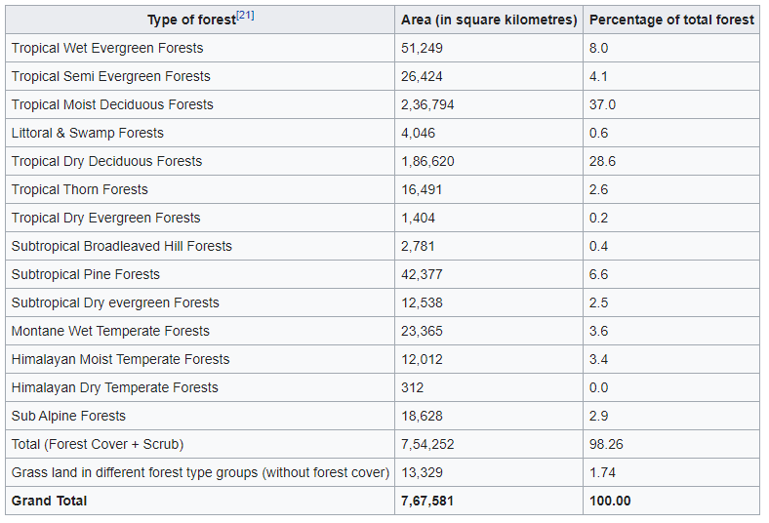

**CHAPTER 4**

**METHODOLOGY**

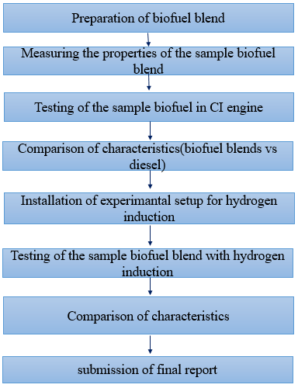

**4.1 EXTRACTION OF TURPENTINE OIL**

**4.1.1 STEP 1 – COLLECTION OF PINE SAPS**

Turpentine were collected from the pine tree . pine trees are mostly seen in the hill stations . pine saps were collected by Drilling a hole into pine tree using a bit size recommended for your spile. Once your hole is started, insert the spile at a downward angle and gently tap the tapered end in with a hammer. If the sap is running, a drop will appear at the tip of the spile. Hang a covered collection bucket from the spile.  turpentine is obtained by the steam distillation of dead, shredded bits of pine wood, while gum turpentine results from the distillation of the exudate of the living pine tree obtained by tapping



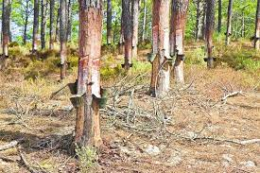

**FIG 4.1 PINE SAPS FIG 4.2 PINETREE**

**4.1.2 STEP 2 - EXTRACTION OF RAW OIL:**

The collected oil was initially filtered and pre-treated for removal of suspended as well as unwanted/foreign particles. The collected saps are crushed using oil crusher to obtain raw oil.

**4.1.3 STEP 3 - PREPARATION OF DIESEL-TURPENTINE BLENDS:**

Diesel was blended with turpentine oil in the ratio of 20%(D80T20),30%(D70T30), 40%(D60T40) , 50%(D50T50) and the engine test was carried out .

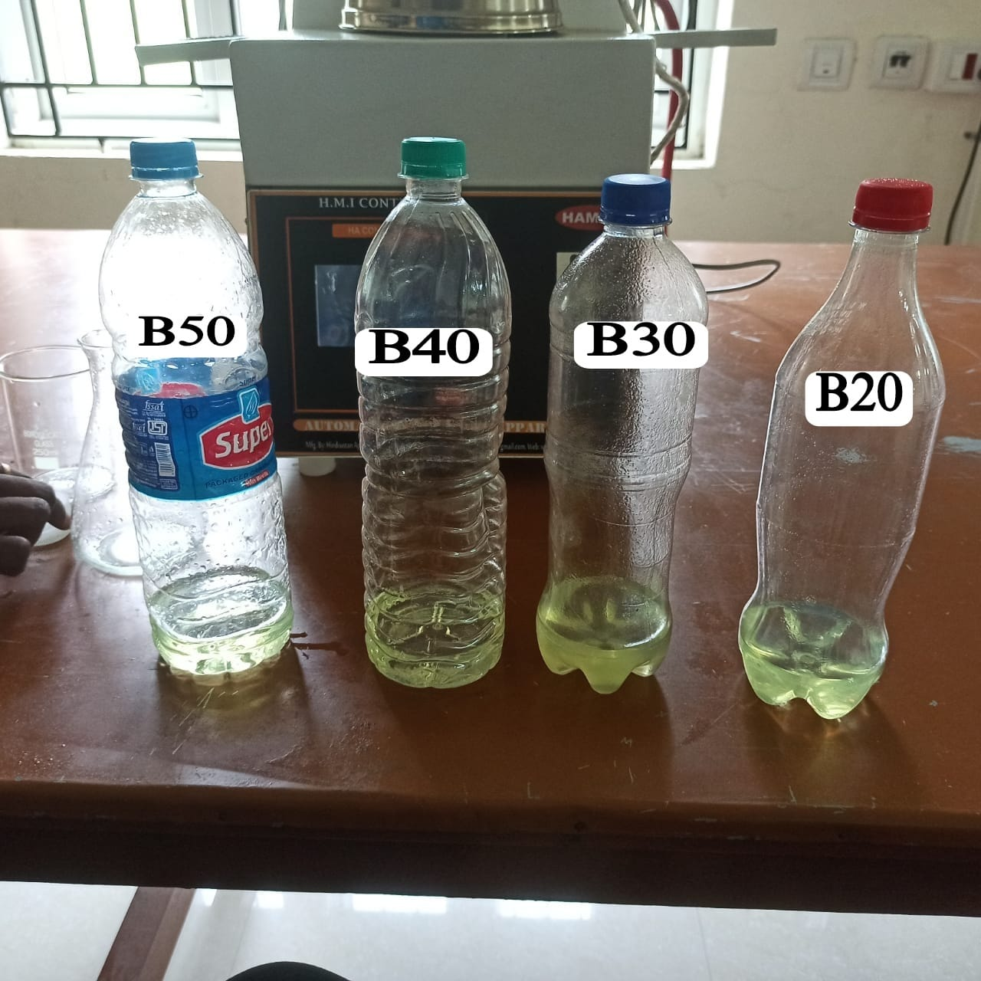

**Fig 4.3 DIESEL-TURPENTINE BLENDS**

## **HYDROGEN INDUCTION**:

Although Biodiesel is a good alternate source of fuel for IC engines, the efficiency of biodiesel is quite low compared with diesel. This problem can be rectified in two ways,

* Fuel Modification
* Engine Modification

For our project, we have choosen Engine modification – dual fuel operation technique for fuel efficiency optimization

## **4.2.1 DUAL FUEL OPERATION:**

A gaseous fuel with high octane number is inducted along with air through intake manifold. The resulting homogeneous mixture is compressed to a temperature below its self ignition point.

A pilot fuel (diesel) is injected through the standard injection system. This self ignites and initiates the combustion.

The hydrogen supply system comprises of following components

1. Hydrogen storage Tank
2. Pressure relief valve
3. Flame trap
4. Flowmeter
5. Connecting Tubes

## **4.2.2 HYDROGEN STORAGE TANK:**

Hydrogen storage tank is a cylindrical metallic Container which stores hydrogen in a compressed gaseous State.

Hydrogen was stored under the pressure of 260 bar in this cylinder.

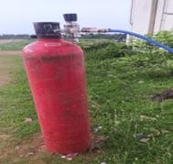

**Fig 4.4 HYDROGEN TANK**

# **4.2.3PRESSURE REGULATOR:**

A pressure regulator is a valve that controls the pressure of a fluid or gas to a desired value, using negative feedback of controlled pressure.

The primary function is to match the flow of gas through the regulator to the demand of gas placed upon it.

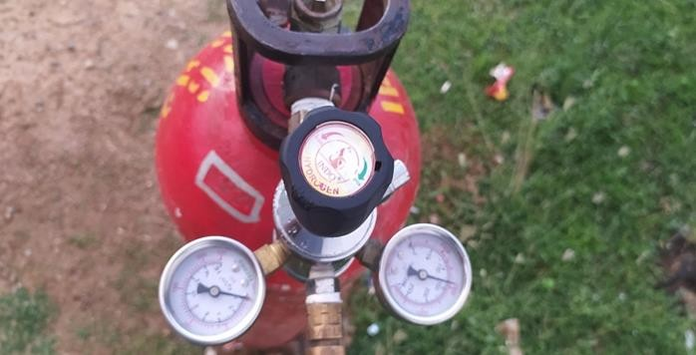

**Fig 4.5 PRESSURE REGULATOR**

The pressure regulator works by monitoring the pressure of the incoming hydrogen gas and adjusting it to a predetermined level. It consists of a diaphragm or a piston mechanism that responds to changes in pressure. When the pressure exceeds the desired level, the regulator restricts the flow of hydrogen to decrease the pressure. Conversely, if the pressure drops below the set point, the regulator opens up to allow more hydrogen gas to flow, thus increasing the pressure.

# **4.2.4 FLAME TRAP:**

A flame trap or flame arrestor is used to arrest backfire in H2 supply line which reduces the risk of explosion.

Flame Trap is a metallic container filled with water along wit h inlet and outlet openings.

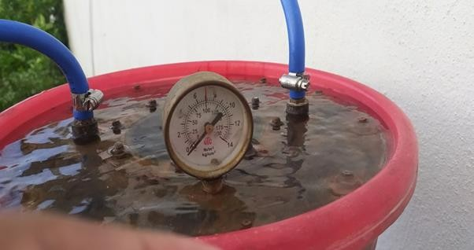

**Fig 4.6 FLAME TRAP**

# **FLOW METER:**

Flow meter is connected next to flame trap to measure the flow of hydrogen. It measures the supply of hydrogen gas in Litre Per Minute(LPM).

The knob in the flow meter is used to induct the hydrogen gas in required LPM.

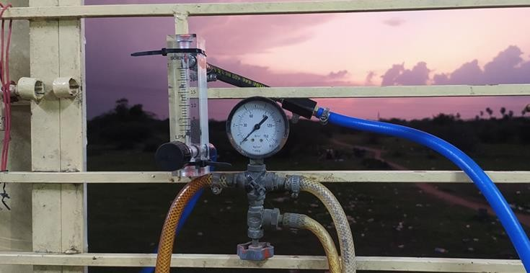

**Fig 4.7 FLOW METER**

# **INDUCTION AT INTAKE MANIFOLD:**

The hydrogen gas is inducted into the engine via intake manifold along with the atmospheric air.

Throughout this experiment hydrogen is inducted at 1 atmospheric pressure.

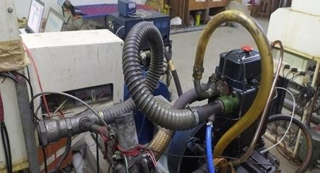

**Fig 4.8 INTAKE MANIFOLD SETUP**

**CHAPTER 5**

**PROPERTIES**

**5.1 : PROPERTIES OF TURPENTINE OIL BLENDS:**

**5.1.1 : KINEMATIC VISCOSITY:**

The kinematic viscosity of a fluid is the ratio of the viscosity of the fluid to the fluid's density. Mathematically, it is expressed as:

ν = μ / ρ

where *ν* is the kinematic viscosity, *μ* is the dynamic viscosity, and*ρ* is the density.

The kinematic viscosity is an important fuel property which affects the atomization of a fuel upon injection into the combustion chamber. The values of diesel and turpentine oil are very close, when compared to other bio diesels. Hence, as the viscosity is less, the fuel is atomized properly, resulting in a complete combustion and good engine performance.

**5.1.2 FLASH POINT:**

The flash point is the lowest temperature at which a volatile substance evaporates to form an ignitable mixture with air in the presence of an igneous source and continues burning after the trigger source is removed. Flash point is a significant property not for the operability of a diesel fuel, but for its storage and handling. Diesel fuels are classified as nonvolatile fuels, and their storage does not need specific precautions. Flash point is an excellent indication of diesel fuel contamination with more volatile products.

**5.1.3 DENSITY:**

The density of material shows the denseness of that material in a specific given area. A material’s density is defined as its mass per unit volume. Density is essentially a measurement of how tightly matter is packed together. It is a unique physical property for a particular object. The principle of density was discovered by the Greek scientist Archimedes. It is easy to calculate density if you know the formula and understand the related units The symbol ρ represents density or it can also be represented by the letter D.

**5.1.4 CALORIFIC VALUE:**

Calorific value is defined as the amount of heat energy released during complete combustion of a unit mass of a fuel. It is expressed in kJ/kg.

**5.2 INSTRUMENTS USED TO MEASURE PROPERTIES**

**5.2.1 REDWOOD VISCOMETER**

The redwood viscometer consist of vertical cylindrical oil cup with an orifice in the centre of its base . The orifice can be closed by a ball . A hook pointing upward serve as a guide mark for filling the oil . The cylindrical cup is surrounded by the water bath . The water bath maintain the temperature of the oil to be tested at constant temperature . The oil is heated by heating the water bath by means of an immersed electric heater in the water bath , The provision is made for stirring the water , to maintain the uniform temperature in the water bath and to place the thermometer ti record the temperature of oil and water bath . The cylinder is 47.625mm in diameter and 88.90mm deep . The orifice is 1.70mm in diameter and 12mm in length , This viscometer is used to determine the kinematic viscosity of the oil. From the kinematic viscosity the dynamic viscosity is determined.

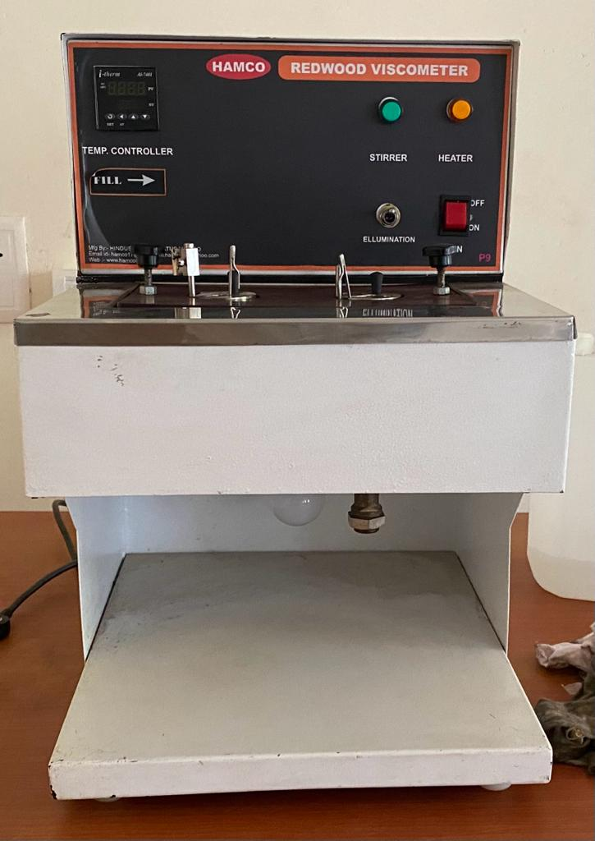

**Fig 5.1 REDWOOD VISCOMETER**

**5.2.2 DIGITAL DENSITY METERS**

Density meters are instruments that measure the density of a sample liquid or gas. Digital density meters are used in the pharmaceutical, petroleum, chemical, and food and beverage industries for quality control and in research and development. Density meters work by measuring the oscillation of a glass tube that contains the sample. There are digital density meters that can measure specific gravity and refraction index as well as the density of a sample. There are density meters available that are portable or bench top models, that can measure liquid, gas, or both, and have a built in thermostat or need a water bath to maintain temperature. Some other variations include sample volume needed, speed of testing, and the ability to take and store images.

The density of a material is defined as its mass per volume. The most common units for density are the SI unit kilogram per cubic meter (kg/m³) and the cgs unit gram per cubic centimeter (g/cm³).

Formula to calculate density = mass/volume

ρ =m/v (kg/m³)

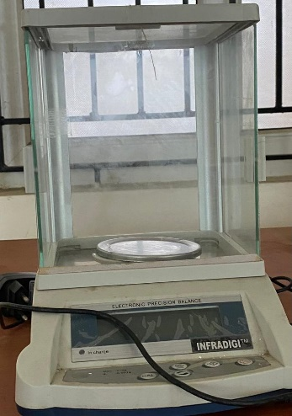

**Fig 5.2 DIGITAL DENSITY METER**

**5.2.3 OPEN CUP APPARATUS**

The Cleveland open-cup method is one of three main methods in chemistry for determining the [flashpoint](https://en.wikipedia.org/wiki/Flash_point) of a [petroleum](https://en.wikipedia.org/wiki/Petroleum) product using a Cleveland open-cup apparatus, also known as a Cleveland open-cup tester. First, the test cup of the apparatus (usually brass) is filled to a certain level with a portion of the product. Then, the temperature of this chemical is increased rapidly and then at a slow, constant rate as it approaches the theoretical flash point. The increase in temperature will cause the chemical to begin to produce flammable [vapor](https://en.wikipedia.org/wiki/Vapor) in increasing quantities and density

Wash the test cup with an appropriate solvent to remove any oil or traces of gum or residue reaming from a previous test. If any deposits of carbon are present, they may be removed with steel wool. Flush the cup with cold water and dry for a few minutes over and open flame or a hot 2 plate to remove the last traces of solvent and water. Cool the cup to a point at least 56*C below the expected flash point before using. Support the thermometer in a vertical position with the bottom of the bulb 6 mm from the bottom of the cup and locate at a point half way between the center and side of the cup on a diameter perpendicular to the are (or line) of the sweep of the test flame and on the side opposite to the test flame burner arm.

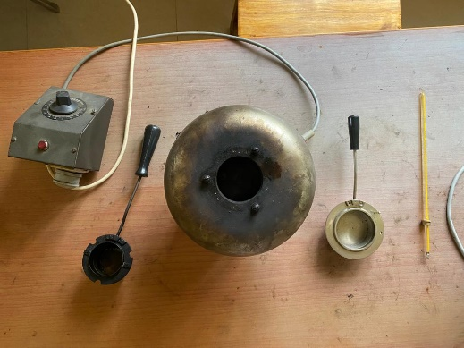

**Fig 5.3 CLEVELAND OPEN CUP APPARATUS**

Thebiodiesel blends and base diesel and turpentine were measured for their properties and the result were given below

**Table 5.1 PROPERTIES OF FUEL**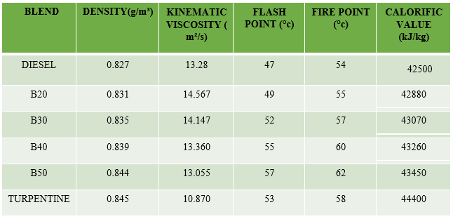

**CHAPTER 6**

**SPECIFICATIONS**

**6.1 ENGINE DESCRIPTION:**

The setup consists of single cylinder, four stroke, Diesel engine connected to eddy current type dynamometer for loading. It is provided with necessary instruments for combustion pressure and crank‐angle measurements. These signals are interfaced to computer through engine indicator for Pθ−PV diagrams. Provision is also made for interfacing airflow, fuel flow, temperatures and load measurement. The setup has stand‐alone panel box consisting of air box, fuel tank, manometer, fuel measuring unit, transmitters for air and fuel flow measurements, process indicator and engine indicator. Rotameters are provided for cooling the water and to measure the water flow. The setup enables study of engine performance for brake power, indicated power, frictional power, BMEP, IMEP, brake thermal efficiency, indicated thermal efficiency, Mechanical efficiency, volumetric efficiency, specific fuel consumption, A/F ratio and heat balance. LabVIEW based Engine Performance Analysis software package “Enginesoft” was used for performance evaluation. A computerized Diesel injection pressure measurement was also provided with the setup.

**6.2 FEATURES:**

* Online measurements and performance analysis
* PӨ‐PV plots, performance plots and tabulated results
* Configurable graphs
* IP, IMEP, FP indication
* Combustion analysis

**6.3 ENGINE LAYOUT:**

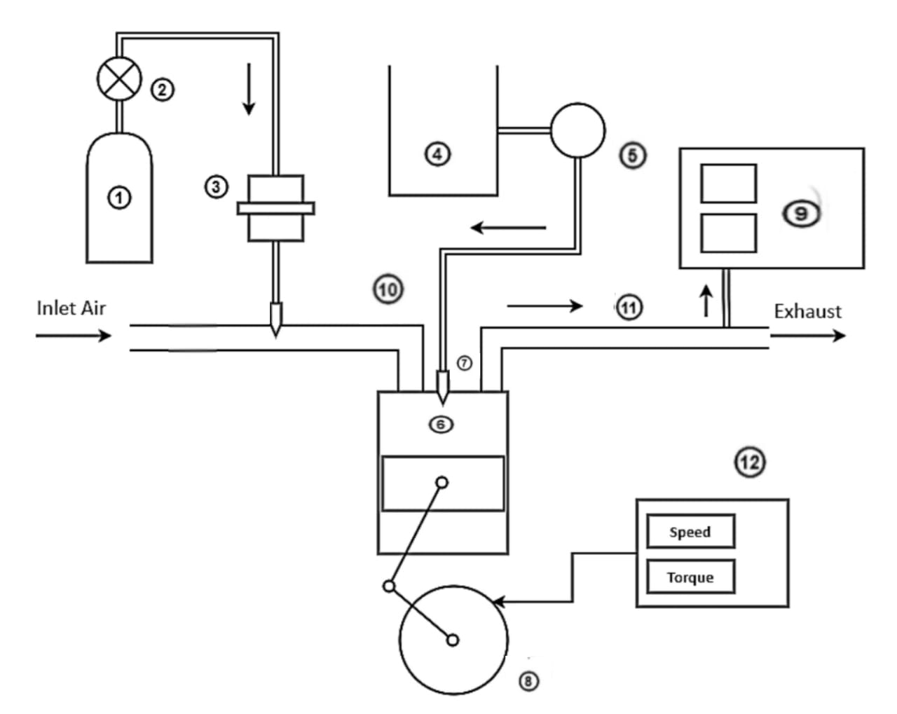

**Fig 6.1 ENGINE LAYOUT**

#### 

**⑨ -**  Exhaust Gas Analyzer

**⑩ -** Inlet Manifold

**⑪ -** Exhaust Manifold

**⑫ -** Dynamometer

**① -** Hydrogen Storage Tank

**② -** Pressure Regulator

**③** **-** Flame Arrestor

**④** **-** biodiesel-Diesel blend tank

**⑤** **-** Fuel Pump

**⑥** **-** Diesel Engine

**⑦ -** Fuel Injector

**⑧ -** Crank Wheel

**6.4 UTILITIES REQUIRED:**

* Electric supply 230 +/‐ 10 VAC, 50 Hz
* 1Phase Computer IBM compatible with standard configuration Water supply Continuous
* clean and soft water supply @ 1000 LPH, at 10 m. head
* Provide tap with 1” BSP size connection
  1. **ENGINE SPECIFICATIONS:**

**Table 6.1 ENGINEE SPECIFICATIONS**

|  |  |
| --- | --- |
| Product | Engine test setup 1 cylinder, 4 stroke, Diesel  (Computerized) |
| Product code | 224 |
| Engine | Make Kirloskar, Model TV1, Type 1 cylinder, 4 stroke Diesel, water cooled, power 5.2 kW at 1500 rpm, stroke 110 mm, bore 87.5 mm. 661 cc, CR 17.5 |
| Dynamometer | Type eddy current, water cooled |
| Propeller shaft | With Universal joints |
| Air box | M S fabricated with orifice meter and manometer |
| Fuel tank | Capacity 15 lit with glass fuel metering column |
| Calorimeter | Type Pipe in pipe |
| Piezo sensor | Range 5000 PSI, with low noise cable |
| Crank angle sensor | Resolution 1 Deg, Speed 5500 RPM with  TDC pulse |
| Data acquisition device | NI USB‐6210, 16‐bit, 250kS/s. |
| Piezo powering unit | Model AX‐409 |
| Temperature sensor | Type RTD, PT100 and Thermocouple, Type  K |
| Temperature transmitter | Type two wire, Input RTD PT100, Range 0–  100 DegC, I/P Thermocouple, Range 0–1200  DegC, O/P 4–20mA |
| Load indicator | Digital, Range 0‐50 Kg, Supply 230VAC |
| Load sensor | Load cell, type strain gauge, range 0‐50 Kg |
| Fuel flow transmitter | DP transmitter, Range 0‐500 mm WC |
| Air flow transmitter | Pressure transmitter, Range (‐) 250 mm WC |
| Software | “Enginesoft” Engine performance analysis software |

**6.6 SOFTWARE:**

EngineSoft is LabVIEW based software package developed by Apex Innovations Pvt. Ltd. for engine performance monitoring system. EngineSoft can serve most of the engine testing application needs including monitoring, reporting, data entry, data logging. The software evaluates power, efficiencies, fuel consumption and heat release. It is configurable as per engine set up. Various graphs are obtained at different operating condition. While on line testing of the engine in RUN mode necessary signals are scanned, stored and presented in graph. Stored data file is accessed to view the data graphical and tabular formats. The results and graphs can be printed. The data in excel format can be used for further analysis.

**6.7 EXHAUST GAS ANALYSER:**

The AVL-DI gas analyzer is an instrument used to measure HC, CO, NOx, CO2, and O2 emissions in the diesel engine exhaust.It is based on the nondispersive infrared rays technique to measure pollutants . NDIR technique is adopted to measure the pollutants HC CO and CO2 and the electrochemical measurement principle is adapted to measure O2 concentration and NOx in the exhaust. Before usage, the analyzer is allowed to warm up for a few hours. A leak check test is carried out by closing the inlet of the analyzer and avoiding the leakage of exhaust gases. This is followed by the HC residue test where all the HC and carbon particles and deposits inside to analyzer for accurate results. The compressed air is supplied over the exhaust probe to 46 remove moisture water droplets, carbon deposits, and blockage inside the exhaust probe before it is connected to the analyzer.



#### 

**Fig 6.2** **AVL-DI GAS ANALYZER**

**6.8 SMOKE METER:**

#### AVL 437C smoke meters are used to analyze the smoke emission levels from the test engine. AVL smoke meter uses the light opacity technique, where light is passed through the exhaust sample and the opacity is measured by a photovoltaic cell. The opacity is a direct measure of smoke intensity.

#### 

#### 

#### 

**Fig 6.3 AVL SMOKE METER**

**CHAPTER 7**

**PERFORMANCE, COMBUSTION AND EMISSION**

**CHARACTERISTICS**

**7.1 PERFORMANCE PARAMETERS:**

**7.1.1 BRAKE THERMAL EFFICIENCY:**

#### 

#### **Fig 7.1 BTE vs LOAD**

The Brake Thermal Efficiency of various fuels namely neat diesel, diesel-turpentine blends namely B20,B30,B40 and B50 and Hydrogen induction with B20 and B30 at various brake power conditions are plotted as a graph and the results are analyzed. It is observed that brake thermal efficiencies of diesel-turpentine blends decreases with increase in percentage of turpentine because of poor volatilability and inferior combustion characteristics of the biofuel. The brake thermal efficiency increases with the induction of hydrogen.The increase of brake thermal efficiency is due to the high flame velocity of hydrogen added to the intake air which increases the combustion rate during combustion.The barke thermal efficiency at full load for the blend B30 with hydrogen induction is 33%.

**7.12 SPECIFIC FUEL CONSUMPTION:**



**Fig 7.2 SFC vs LOAD**

The specific fuel consumption of various diesel-turpentine blends namely B20,B30,B40,B50 and hydrogen induction with B20 and B30 were plotted against various loads. It was found that the SFC of the diesel-turpentine blends were found to increased than the diesel. This is due to the lower calorific values of the biofuel blends than the diesel. When using hydrogen as fuel, it is found that the SFC was decreased than the neat diesel, because of the superior calorific value for hydrogen. Therefore hydrogen will be a better fuel source for the fuel economy.

**7.2 COMBUSTION PARAMETERS:**

**7.2.1 IN-CYLINDER PRESSURE:**

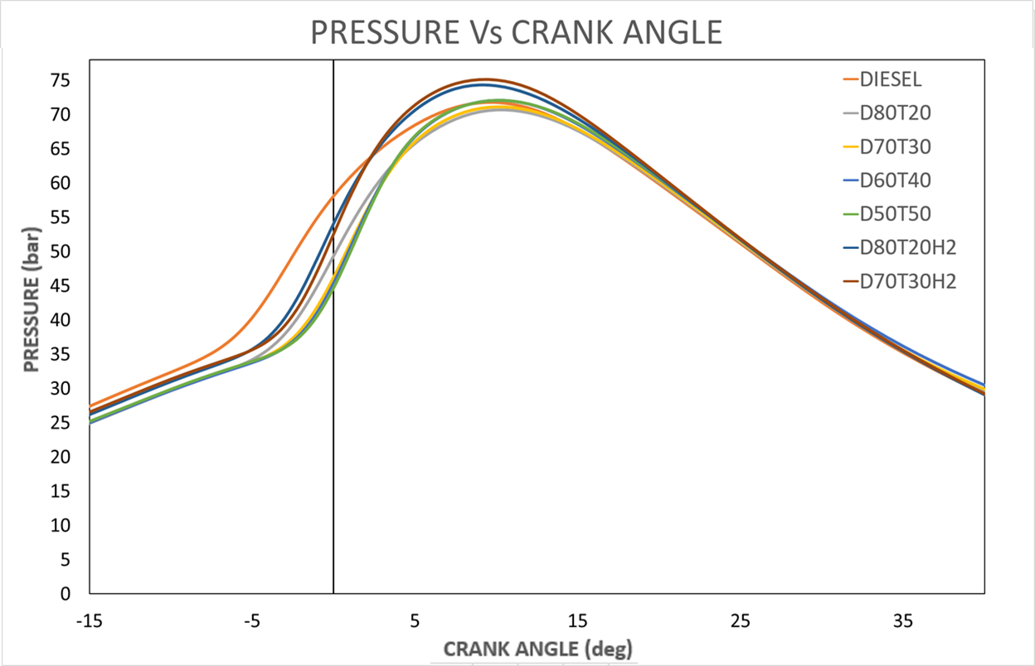

#### **Fig 7.3 CRANK ANGLE vs PRESSURE**

The cylinder pressure obtained using the pressure sensor at various crank angle is plotted. Pressure variations of neat diesel,diesel-turpentine blends B20, B30,B40, B50 and hydrogen induction with B20 and B30 is seen in the above graph. There is a drop in the peak pressure of the blend B20 when compared to the neat diesel fuel. The reduced pressure produced by the biofuel was due to lower calorific value which means lower heat releasing capacity. Also, there is improper combustion of fuel samples due to lower volatility and higher viscosity. The combined effect of all these conditions, leads to reduction in the peak pressure produced during combustion by the biofuel than neat diesel fuel. But an increase in the peak pressure is seen when inducting hydrogen gas along with the intake air in the intake manifold. This pressure increase may be attributed to the higher flame velocity of the hydrogen and the better oxidation of the premixed charge in the combustion chamber.

**7.2.2 HEAT RELEASE RATE:**



#### **Fig 7.4 CRANK ANGLE vs HEAT RELEASE RATE**

The heat released by various fuels namely neat diesel, diesel-turpentine blends B20, B30, B40, B50 and hydrogen induction with B20 and B30 at various loading conditions are plotted and the results are analysed. It is seen that a negative HRR value was obtained before starting the combustion. This is due to the evaporation of the liquid fuel accumulated during the ignition delay period and the heat absorption from the environment. The HRR value move towards positive when the combustion started. The lesser HRR of the blend B20 is mainly due to the lower calorific value of the biofuel. Due to this, the amount of heat released on the combustion of this fuel also tends to be lesser. But there is a drastic rise in the values of HRR with hydrogen enrichment. The higher flame velocity of hydrogen will result in increased premixed combustion. This is due to the increased ignition delay of hydrogen. It is stated that hydrogen has a more significant effect on premixed combustion phase compared than on diffusion combustion phase.

**7.3 EMISSION PARAMETERS:**

**7.3.1 HYDROCARBON EMISSION:**



#### **Fig 7.5 LOAD vs HC**

#### 

Variation of HC with operating load conditions for the neat diesel, B20, B30, B40, B50 and hydrogen induction with B20 and B30 is shown in the above graph. Compared to the diesel-turpentine fuel, diesel gives lesser HC emissions due the presence of more oxygen in it. Presence of oxygen enhances the rate of combustion. Hence the emission of unburnt hydrocarbons is automatically reduced. Further reduction in HC emissions is noted with hydrogen induction with B30. The rapid burningrate of the hydrogen induces complete combustion of the biodiesel. Hence this explains the reduction in the amount of HC with hydrogen enrichment.

**7.3.2** **CARBON MONOXIDE EMISSIONS:**



#### **Fig 7.6 LOAD vs CO**

Carbon monoxide is one of the compounds formed during the intermediate combustion stages of hydrocarbon fuels. As combustion proceeds to completion, oxidation of CO to CO2 occurs through recombination reactions between CO and the different oxidants. If these recombination reactions are incomplete due to lack of oxidants or due to low gas temperatures, CO will be left. Variation of CO emissions with operating load conditions for the neat diesel, B20, B30, B40, B50 and hydrogen induction with B20 and B30 is shown in the above graph. The main reason for reduction in CO emission is the more amount of oxygen and lesser carbon content in biofuel. The excess oxygen present in the biofuel reacts with the CO and facilitates the oxidation of CO into CO2. During hydrogen induction, higher flame velocity of the hydrogen will also increase the combustion rate. Hence the CO emissions are reduced.

**7.3.3** **SMOKE OPACITY:**



#### **Fig 7.7 LOAD vs SMOKE**

Smoke is also seen as a result of incomplete combustion. Variation of smoke opacity with operating load conditions for the neat diesel, B20, B30, B40 and B50 and hydrogen induction with B20 and B30 is shown in the above graph. It is observed that the smoke emissions increased due to the lower heating capacity of the turpentine-diesel blends. when the load increases the percentage of smoke also increases. At low loads the percentage of smoke is lower and as the load increases the smoke emission increased. Additionally, the induction of hydrogen has shown a substantial reduction in smoke emissions. This is due to the enhancement in the combustion by secondary oxidation, which burns the unburned soot particles present in the cylinder

**7.3.4** **OXIDES OF NITROGEN:**



#### **Fig 7.8 LOAD vs NOX**

According to the Zeldovich mechanism, the excess oxygen molecules will dissociate into atomic oxygen and these will react with the nitrogen molecules forming NO emissions. These take place during conditions of high temperature.

Variation of NOx emissions with operating load conditions for the neat diesel, B20, B30, B40 and B50 and hydrogen induction with B20 and B30 fuel is shown in the above graph. At low loads, the emission of NOx decreases with the addition of turpentine-diesel. AT high loads, the NOx emissions increases. Hydrogen enrichment will also lead to a further increase in the amount of NOx emitted. Because of the higher calorific value of the hydrogen, more amount of heat is released and hence the in-cylinder temperature is also increased. This explains the increased NOx emissions during hydrogen induction.

### CHAPTER 8

**CONCLUSION**

In this project, the effect of turpentine oil biofuel with hydrogen induction in single cylinder diesel engine its effect on performance, combustion and emission characteristic is studied. The following conclusions are derived:

1. The brake thermal efficiency in CI engine has decreased with the Turpentine-diesel blend. This is due to the low heating capacity of the turpentine-diesel blends. The BTE of B20 and B30 blend was found as 31.92% and 31.71% respectively The BTE was increased when induction with hydrogen. The BTE of B30 blend with hydrogen induction was 33%.
2. The specific fuel consumption was increased for the diesel-turpentine blends than the diesel. but the induction of hydrogen decreases the SFC for the B20 and B30 blends.
3. The Diesel when compared to the biofuel blends produces a higher in-cylinder pressure and heat release rate due to the higher flame velocity and good combustion rate. Also when using hydrogen, the combustion pressure and the net heat release rate of the biofuel blends was increased due to superior combustion characteristics of hydrogen.
4. The CO emissions of the biofuel blends were reduced. At full load, the CO was found to be 285% and 276% for B20 and B30 blends respectively. With hydrogen induction, the CO was found to be 191% and 110% for B20 and B30 blend.
5. At low load, the biofuel blends shows decrease in NOx emissions. At low load, the NOx was found to be 121 and 95 ppm for B20 and B30 blend. At full loads with induction of hydrogen increases the NOx emissions drastically. The NOx at full load with hydrogen induction for B20 and B30 blends were 2513 and 2678 ppm.
6. The smoke and HC emissions of the biofuel blends with hydrogen induction were decreased when compared to the other biofuel blends. At full loads, the smoke percentage for B20 and B30 with hydrogen induction were 50% and 45% respectively and the percentage of HC was 70% and 49% respectively.

**REFERENCES:**

1. M. Kannan, G. Elavarasan, D. Karthikeyan, Vikas Goyat.

Analysis of emission and performance characteristics of compression

ignition engine using Mahua oil-based biodiesel

2.Tomesh Kumar Sahu, Sumit Sarkar, Pravesh Chandra Shukla.

Combustion investigation of waste cooking oil (WCO) with varying

compression ratio in a single cylinder CI engine

3 . Mehmet Hakkı Alma, Tufan Salan

A review on novel bio-fuel from Turpentine oil.

4 . Anil singh yadav , Padam singh , Rahul sahu , p. Thangamuthu ,

Renuka shyam narain , y. Anupam rao

potential utilization of turpentine oil a an alternative fuel

5. a.k. jeevanantham , d. madhusudan reddy , neel goyal , aman kumar

experimental study on the effect of cetane improver

with turpentine oil onci engine characteristics